AWS ROOT PASSWORD RECOVERY
First launch two instances prod-server
Dev-server
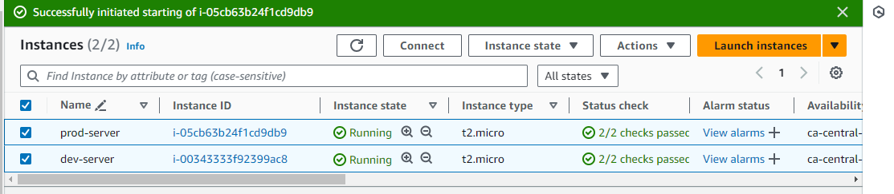

Now select prod-server and login to public ip with putty. Then go to sshd configuration file given to root access.
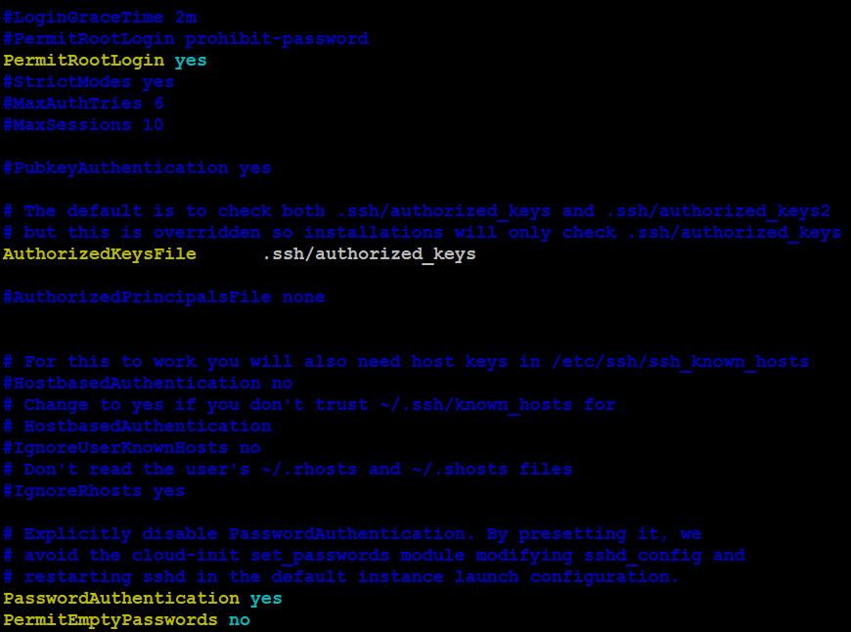

Then restart sshd service and assing root user give password and check the root password.
Then root password will be lock manually.

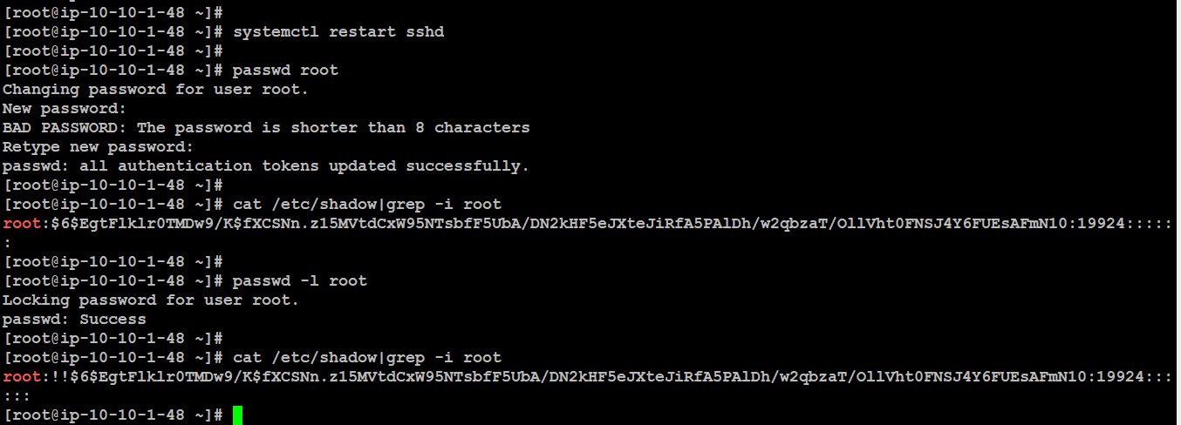

Now prod-server unable to login with root password. Then to reset the root password.
Now stop the aws prod-server.
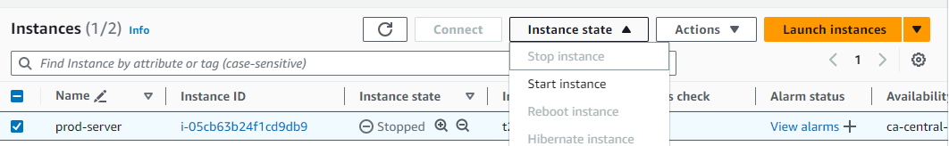

Next go to volumes and dropdown actions and detach volume prod-server.

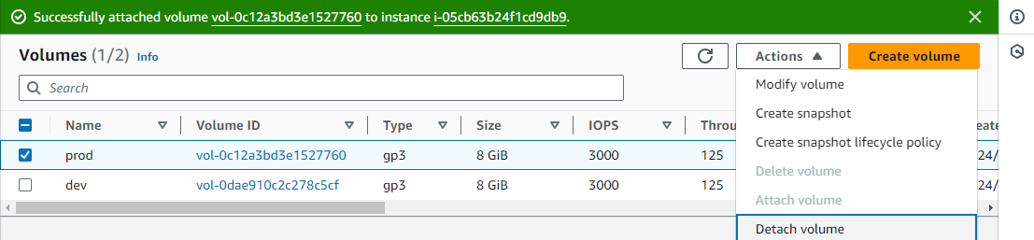
Now attach the prod-server volume to dev-server.

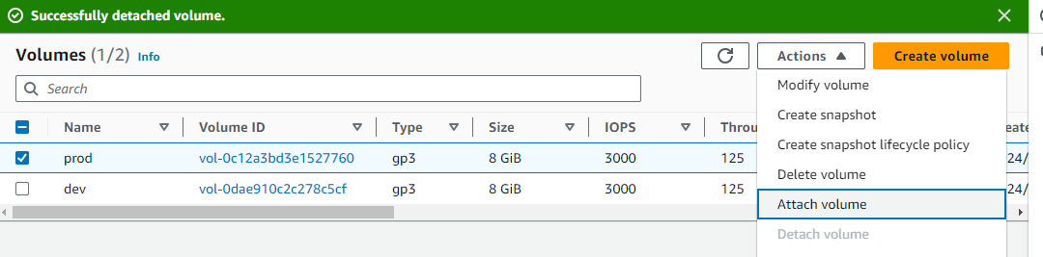

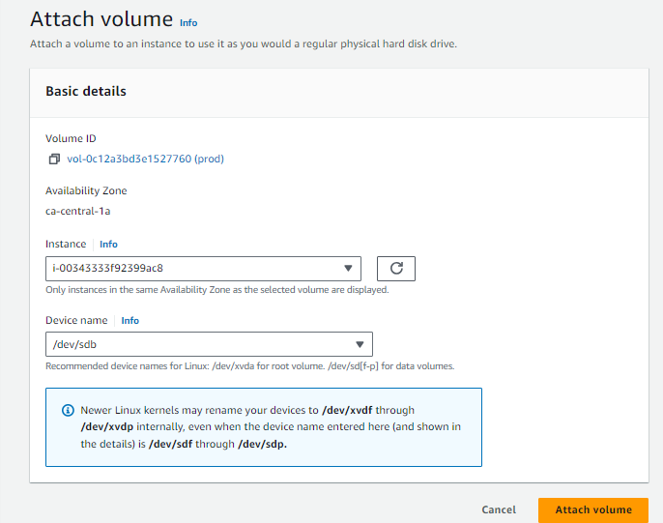

Here instance select dev-server and select the device name /dev/sdb

Now login dev-server with public ip to putty.
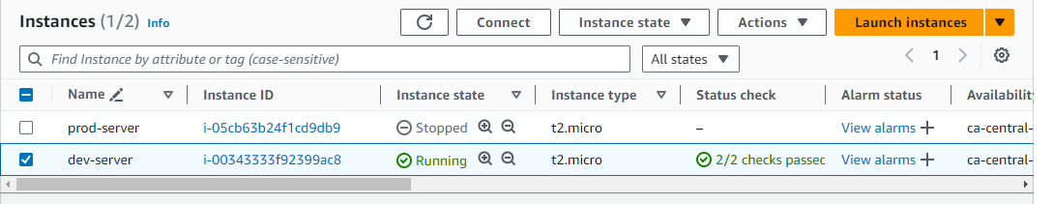
To check disk scan or not and check blkid sda1 and sdb1 are same uuid number.

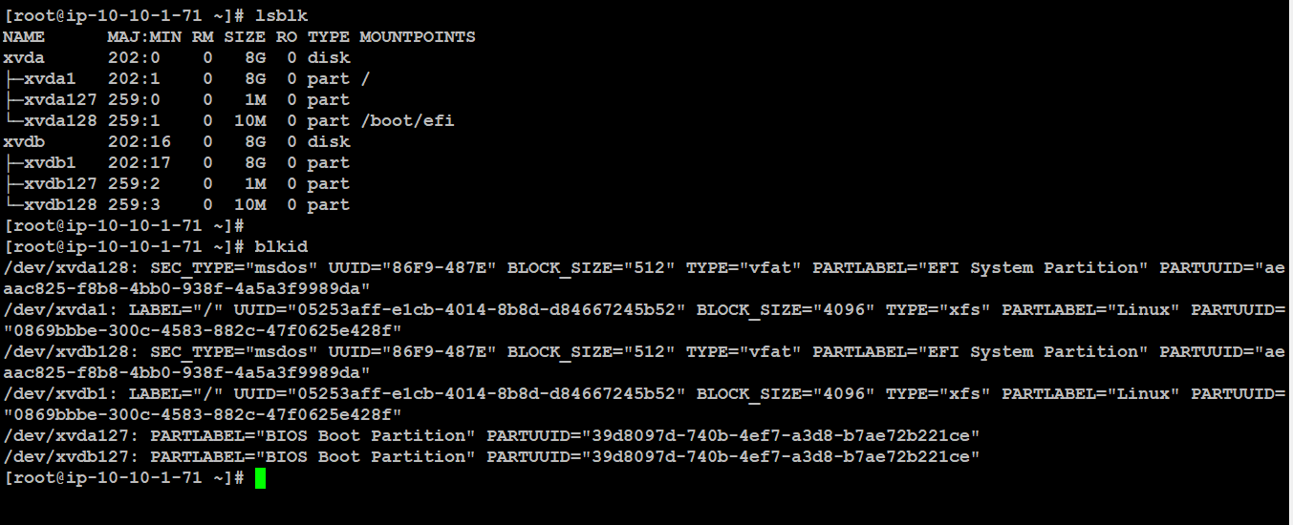
To mount the file system to /mnt to /dev/sdb dev-server attached instance. and check the mounted file system information.
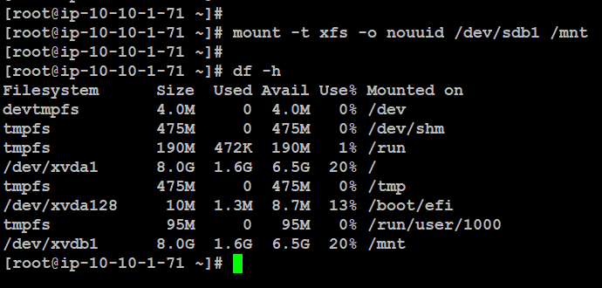
To create user and assign user krish1 password should be root123 .

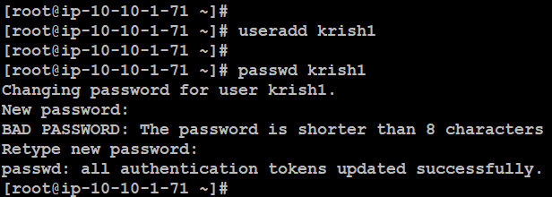
Next here krish1 encrypted password copy and paste to root user shadow file.
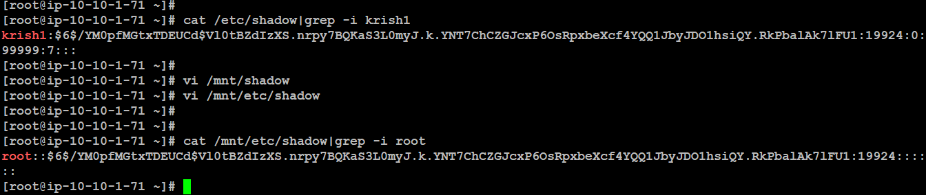

Then go to volumes and dropdown actions detach the volume of prod-server (before attached volume / disk).
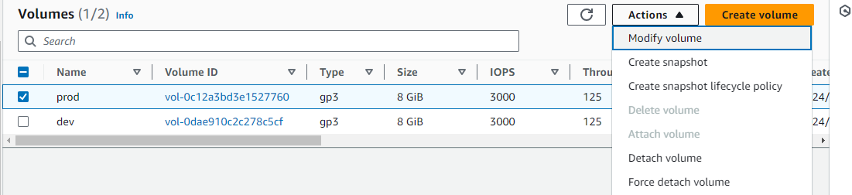
To detach the volume.
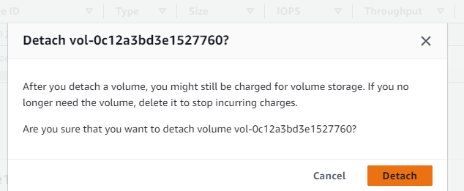
Now attach to volume to prod-server (unable to login to root password server).

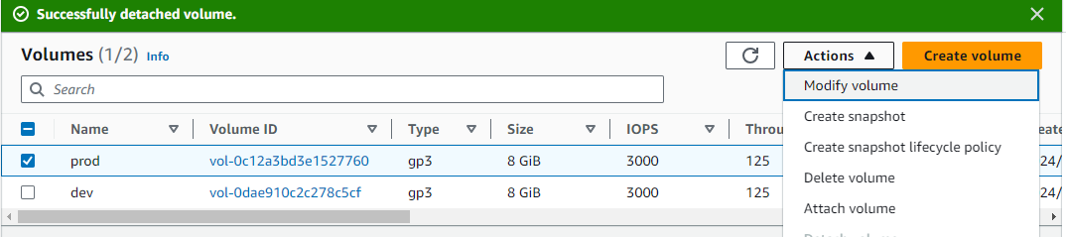

Here selects the instance which is stopped instance i.e prod-server and select device name /dev/sda is root disk.

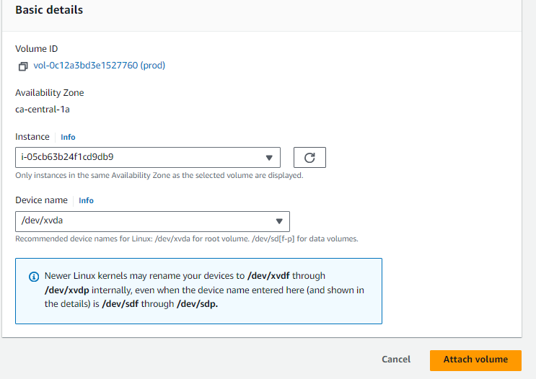

Finally go to instances and start the prod-server .
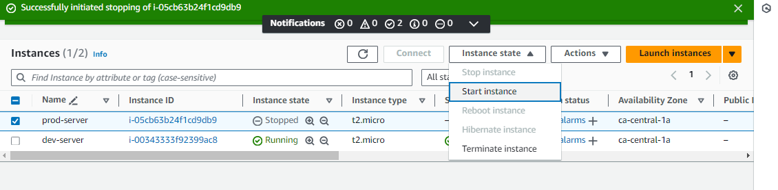
So finally login to root password successfully. So to reset the aws password.
